86K for a Cure Templates
Below you will find a range of email templates designed to help you recruit, engage and inspire your organisation. As is the name, these are just templates so please feel free to add your own spin or reach out if there is something specific you had in mind.

Recruitment template Pg. 2
Engagement template (Leaderboard) Pg. 3
Engagement template (Impact – Jack’s Story) Pg. 4
Start’s Today Pg. 5
Final Day Pg. 6

RECRUITMENT
Hi Team,
I am very excited to let you know ORG NAME are taking on the challenge of 86K for a Cure this March to help change the future of children with cancer!
The challenge: You can choose to walk or run (or swim, cycle, hike, roll etc) 86km across the month of March while raising vital funds for medical research to help find a cure for childhood cancer.
Join our team today by following this link: <INSERT FUNDRAISING PAGE LINK>
Sadly, 86 children are diagnosed with cancer every month. At Children’s Cancer Institute, they believe that a life should be long. That every child should have the chance to chase their dreams and reach their potential.
86K for a Cure is our chance to support these brave kids and help save lives, so please join our team today!
Together, we can get energised, achieve our fitness goals, stay connected and help put an end to childhood cancer. 🏃‍♂️ 🙌
I look forward to welcoming you to our 86K for a Cure team.
Warm Regards

INTRANET / SHORT POSTS
- Are you ready to take on a challenge to help kids with cancer?
✅ Get active and run or walk 86km this March
✅ Raise funds for kids with cancer and help find a cure
✅ Take on a meaningful new challenge and get out of your comfort zone

Join our team today: <TEAM LINK>
- In Australia, more children lose their lives to cancer than any other disease 💔
Conquer 86km this March for the 86 kids diagnosed with cancer each month, to help find a cure for childhood cancer and save lives.
It's FREE – Join our team today: <TEAM LINK>
- Will YOU go the distance for kids with cancer?
Every month in Australia, 86 children are diagnosed with cancer, so we're taking on the challenge to conquer 86km throughout March to help find a cure but we need YOU!
Join our team today: <TEAM LINK>

And if you need an extra incentive, once you raise $86 you’ll receive a FREE t-shirt and welcome pack!
ENGAGEMENT – LEADERBOARD SHOUTOUT
Note: Feel free to update this to share as often as you like. We suggest you do a team/organisation update once a week to keep the friendly competition and engagement high. You can get all the information off your Organisation fundraising page.
Below is an example based on our Children’s Cancer Institute organisation page: https://www.ccia.org.au/fundraisers/ChildrensCancerInstitute/86k-for-a-cure

Hi team!
It’s time for our 86K for a Cure progress update!
Each and every one of you should be so proud of the impact you are making on the future of children with cancer.
Without further ado, our impact so far:
🥁🥁 Drum roll please 🥁🥁
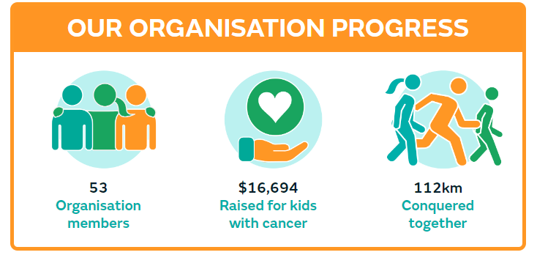
A big shout-out to our top fundraiser <insert name> 👏👏
<INSERT SCREENSHOT OF FUNDRAISER PAGE>
Followed by a shout-out to <Top Team Name> for leading the way on <insert raised amount> - Well done team!

<INSERT SCREENSHOT OF TEAMS>

Every dollar raised and every km conquered is helping Children’s Cancer Institute find a cure for childhood cancer. It’s not if, it’s when.

Keep up the amazing work and eyes peeled for our next update. Will you be on the top of the leaderboard? 👀

Thanks,

ENGAGEMENT – IMPACT (JACK’S STORY)

Hi Team,

As you know we as a team are participating in 86K for a Cure to help find a cure for childhood cancer and today I wanted to share some motivation with you all.

60 years ago, childhood cancer was a death sentence. Today, 8 out of 10 children will survive. But there is much work to be done. Children’s Cancer Institute have made it their mission to cure all children of cancer and won’t stop until it’s done.

By taking on the challenge of 86K for a Cure, you are helping this mission come to life for kids all across Australia. Kids just like Jack.

You can learn about Jack’s inspiring story by watching this video: https://youtu.be/Nb1oSPxapcI

When Jack was 9, he was diagnosed with an inoperable brain tumour and was given months to live.
With no other treatment options, Jack was enrolled onto ‘Zero Childhood Cancer Program’, a clinical trial at Children’s Cancer Institute.
The trial was a huge success. Within just a few days of the new treatment, Jack was sitting up in bed. Six weeks later, he was playing tennis and riding his bike!
“It was incredible. In a matter of days, Jack was transformed back to himself." - Viv, Jack's mum
This March, Jack is walking 86km alongside you to help support researchers so they can continue saving the lives of other children like him.

Together, we can help cure childhood cancer.

Keep up the great work team!

STARTS TODAY

Hi Team,

HAPPY DAY ONE OF 86K FOR A CURE! 🏃‍♂️

Let’s do a quick progress update to see where we are starting the month so we can look back on how far we make it 💪

<INSERT SCREENSHOT OF ORG PROGRESS HERE FROM FUNDRAISING PAGE> E.G.:

<INSERT SCREENSHOT OF INDIVIDUAL AND TEAM TOP FUNDRAISERS>

We have some exciting things planned across the month for 86K for a Cure:

<Insert any plans / internal competitions you organise. Some examples could be:

- Lunchtime walking groups
- Walk and talk meetings
- Incentives for the highest km’s and highest fundraising each week
  - These can be unique to your team. E.g. might be a free coffee, half-day Friday, give the boss a dare or funny hat to wear for the day.
- End of month team lunch to celebrate>

Be sure to keep an eye on your emails across the month for updates from the 86K for a Cure team at Children’s Cancer Institute. If you haven’t been receiving their emails please reach out to Carys at events@ccia.org.au

Don’t forget there are loads of resources including social media tiles and more you can download and share with your networks to rally support. See here: https://www.ccia.org.au/event/86k-for-a-cure/resources

I can’t wait to see what we achieve together as an organisation! Let’s do this for the 86 kids sadly diagnosed with cancer every month 💔💪

Time to get our conquering on!

Thanks
FINAL DAY

Hi Team,

Wow! Our final day of 86K for a cure - what a month this has been.

I hope you have all enjoyed conquering your kilometres in support of the 86 kids sadly diagnosed with cancer every month.

Not only has it been so incredible to be making a true difference in the lives of kids with cancer, but it has been so much fun as a team!

<Insert any key moments of the month. Funny moments, inspiring stories etc>

Together, we have raised an incredible <INSERT AMOUNT RAISED> and conquered <INSERT KMS CONQUERED>! Let’s put in one last big push today to see just how far we can take this 💪

Huge shout-out to our top individuals and teams leading the way in fundraising and km’s conquered:

<INSERT NAMES / SCREENSHOTS OF TOP FUNDRAISERS, TEAMS AND KM’S CONQUERED>

Don’t forget we will be having a team celebration to look back on the amazing impact we have achieve together. <Insert details if you are having a celebration>

Let’s make today our biggest day yet! GO TEAM!

Thanks

