Subject - CEO Dare to Cure 2022- sponsor me to help kids like Brydee
Dear friends and family,
I am proud to be part of Team 2022 participating in Children’s Cancer Institute’s CEO Dare to Cure.
Children's Cancer Institute is the only independent medical research institute in Australia wholly dedicated to curing childhood cancer and pioneering safer treatments.
Every single week in Australia, 20 children are diagnosed with cancer and it still kills more children than any other disease. Children’s Cancer Institute’s goal is to put an end to childhood cancer and pioneer safer treatments for children through medical research.
That’s why this year I have agreed to step out of my comfort zone to take on a dare to show my support for children with cancer.
One of the very special child ambassadors for CEO Dare to Cure is a little girl called Brydee. When Brydee was just 5 months old, doctors found some abnormalities in her white blood cells and tragically, she was diagnosed with leukaemia. Brydee endured what no infant should: months of gruelling chemotherapy and a bone marrow transplant. After a long and hard journey, Brydee is finally on her way to live the life of a normal baby, but she will have to live with the side-effects of her treatment.
Brydee during treatment
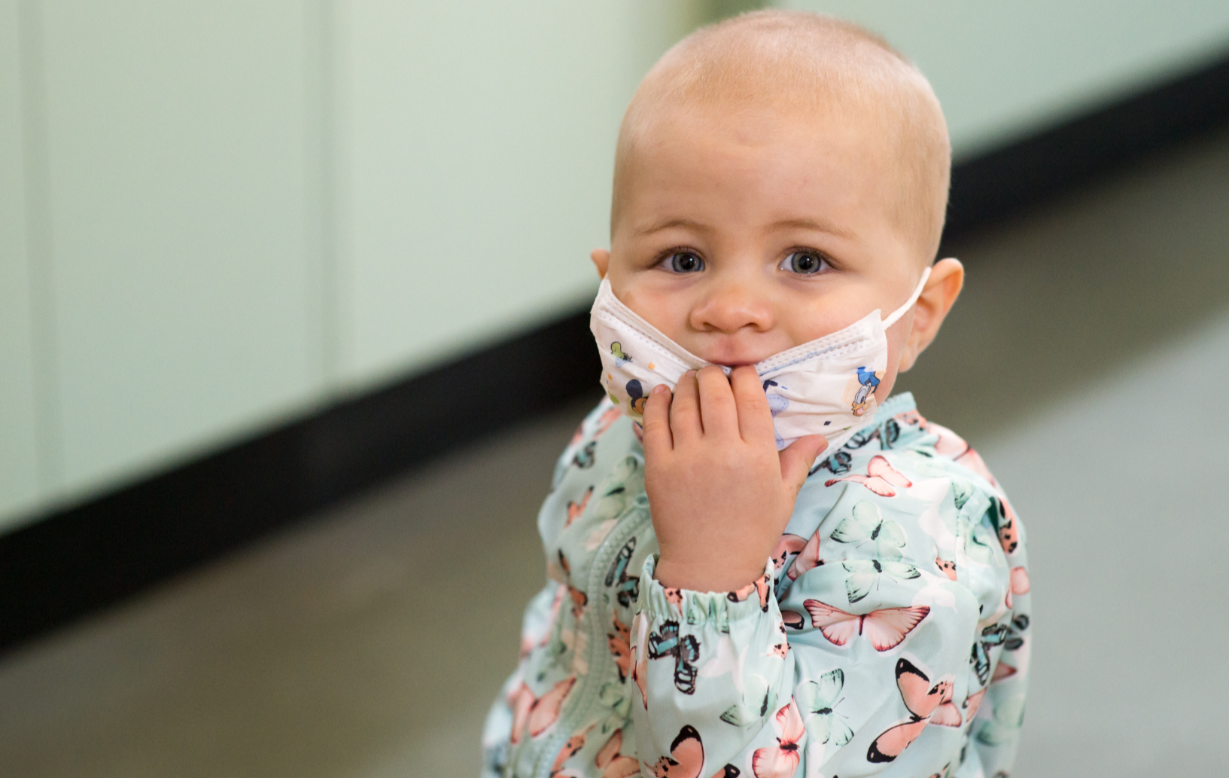
Please get behind this great cause to support children like Brydee and donate on my fundraising page here ( insert unique Fundraising Page link)
Warm Regards,
Name


