Subject - CEO Dare to Cure 2022- sponsor me to help kids like Max
Dear friends and family,
I am proud to be part of Team 2022 participating in Children’s Cancer Institute’s CEO Dare to Cure.
Children's Cancer Institute is the only independent medical research institute in Australia wholly dedicated to curing childhood cancer and pioneering safer treatments.
Every single week in Australia, 20 children are diagnosed with cancer and it still kills more children than any other disease. Children’s Cancer Institute’s goal is to put an end to childhood cancer and pioneer safer treatments for children through medical research.
That’s why this year I have agreed to step out of my comfort zone to take on a dare to show my support for children with cancer.
One of the very special child ambassadors for CEO Dare to Cure is a little boy called Max. Max was a healthy, lively 3-year-old, when he was diagnosed with acute lymphoblastic leukaemia (ALL). Max’s MRD test results were ambivalent, so he experienced a more aggressive treatment regime, which led to harsh side effects. After two years and countless rounds of chemotherapy and steroids, fortunately, Max is alive and well today but his experience has had an impact. “I was ignorant of the reality of how invasive the treatment is, and the devastating impacts it can have on families.” Albina, Max’s Mum.
Max during treatment
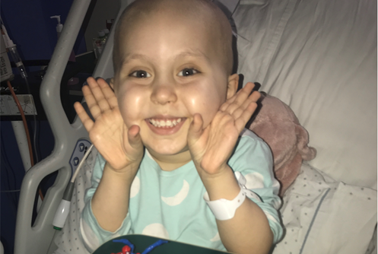
Please get behind this great cause to support children like Max and donate on my fundraising page here (insert unique Fundraising Page link)
Warm Regards,
Name


