Subject - CEO Dare to Cure 2023- sponsor me to help kids like Jacob
Dear friends and family,
I am proud to be part of Team 2023 participating in Children’s Cancer Institute’s CEO Dare to Cure.
Every year in Australia over 1,000 children are diagnosed with cancer. For hundreds of these children, cancer will cut their life short, before they’ve even had a chance to make their mark. In fact, three children die of cancer every week in Australia.
Like you, I believe that a life should be long. That every child should get the chance to grow up and grow old. ​To plan exciting futures, chase their dreams, and fulfil their potential.
That’s why this year I have agreed to step out of my comfort zone and take on a dare to raise funds for Children’s Cancer Institute.
As the only independent medical research institute in Australia wholly dedicated to curing childhood cancer, everything they do is about ensuring that every child with cancer not only survives but goes on to lead a long and healthy life.
Children like Jacob, one of the very special child ambassadors for CEO Dare to Cure.
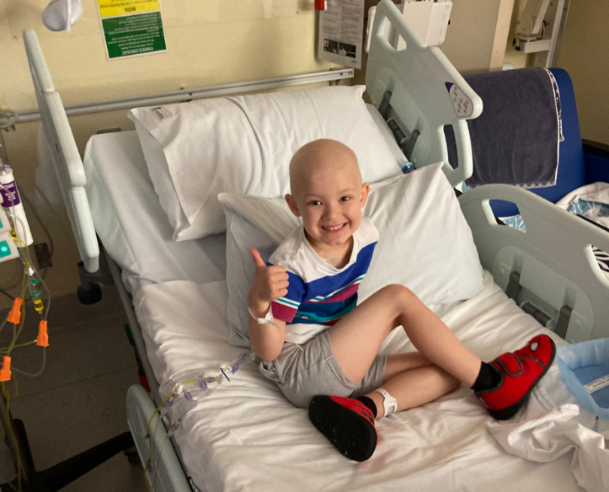
Jacob was diagnosed with acute lymphoblastic leukaemia at just four years of age. He has already been through several cycles of chemotherapy over the past eight months and has experienced a range of debilitating side-effects. He has another 16 months of maintenance therapy to go, then it will be another three years beyond that before he gets the all-clear.
“I can remember sitting and thinking for ages about how to explain cancer to him… a 4-year-old child,” Matt, Jacob’s dad.
Please get behind this great cause to support children like Jacob and donate on my fundraising page here (insert unique Fundraising Page link).
Together we can ensure that not only do kids like Jacob survive, but their hopes and dreams do too.
Warm Regards,
Name
